Scientific Knowledge
Day 5: Lesson Quiz
Choose the letter of the best answer.

1. Scientists think that about 65 million years ago, an asteroid struck Yucatan, Mexico, and created a huge cloud of dust in the atmosphere. The dust contained iridium, an element commonly found in asteroids. The dust cloud blocked the sunlight, killing most of the plants on Earth. Plant-eating dinosaurs starved and, without herbivores as prey, meat-eating dinosaurs died, too. Scientists studied layers of rock from around the time of the strike to confirm their hypothesis. What evidence would support the hypothesis that an asteroid’s impact could have contributed to the extinction of the dinosaurs?
A. a rock layer containing no iridium
B. a rock layer containing fossils of human beings
C. a rock layer containing greater than usual amounts of iridium
D. a rock layer containing fossils from 100 million years ago
2. Karsten is researching a recent, controversial scientific issue. Which of these sources is a reliable source for Karsten to use for unbiased scientific information?
A. an encyclopedia article in a respected, older encyclopedia
B. a scientific journal with peer-reviewed articles
C. a personal website or blog
D. an informative pamphlet mailed to your home by a politician or lobby group
3. Part of cell theory says that all living things are made up of one or more cells. Scientists had to find ways to test this theory. Which investigation could scientists use to test this part of cell theory?
A. heat plant or animal tissue on a hot plate
B. test plant or animal tissue with a pH meter
C. examine plant or animal tissue with a microscope
D. measure the mass of plant or animal tissue with a scale
4. According to Gregor Mendel’s laws of genetic inheritance, when two parents have different genes for a trait, one form of the trait will be dominant and the other recessive. The dominant form normally appears in the offspring. In this illustration, one cat parent has genes for gray fur and the other has genes for white fur. Gray fur is dominant. The gene for gray fur is A. The gene for white fur is a.
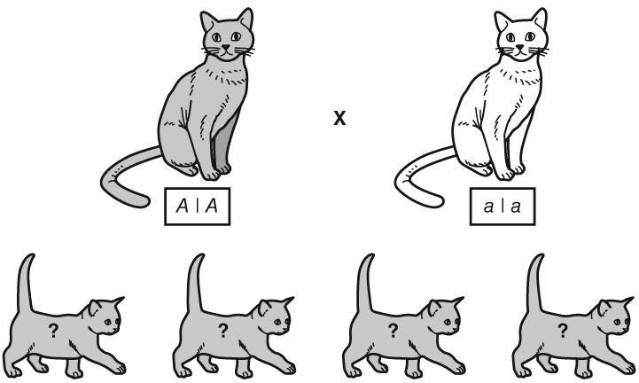
What color would the kittens have to be in order to provide evidence supporting Mendel’s laws?
A. gray
B. white
C. white with gray spots
D. gray stripes
5. Scientists once believed that Earth’s continents were fixed in position. Then scientists began to theorize that the continents started as one large landmass. Today, this idea is commonly accepted as part of the theory of plate tectonics. Which of the following events could have led scientists to change their ideas and accept the theory that Earth’s crust is made of moving plates?
A. the observation of changing sea levels
B. the observation that new rock forms on Earth’s surface
C. the idea that Earth’s core is made of mostly iron and nickel
D. the observation that earthquakes and volcanoes occur along certain lines

